Live Video Streaming - Client Manual

Receiving invitation to join live video stream
When creating a private video streaming session, the presenter will invite each person to the video stream using their email details. The invitees will get an email from livevideostreaming.co.za which contains all the information required to log into the live video stream.
Please see an example of the email that you will receive below:
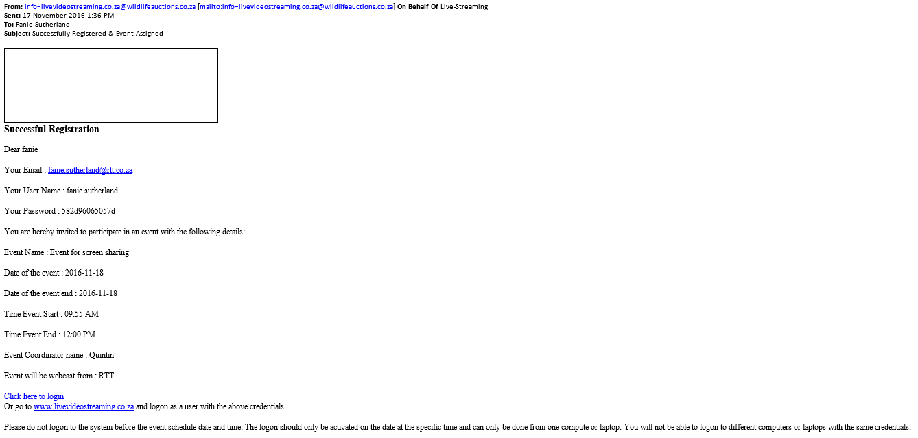
You will note that this email contains all the information that you need to know to join the live video stream.
Please note the following:
- You cannot log in and join the stream before the designated time specified in the email
- You need to use Google Chrome to access the site www.livevideostreaming.co.za
- You may not use the same credentials to login from two different computers
- Please make sure that you allow popups in your Google Chrome browser for the www.livevideostreaming.co.za website.

Logging into live video stream
When logging into the site, you can simply click on the link in the email that you have received, or you can browse to the site www.livevideostreaming.co.za and click on the ‘User Login’ button. You will see the screen below:
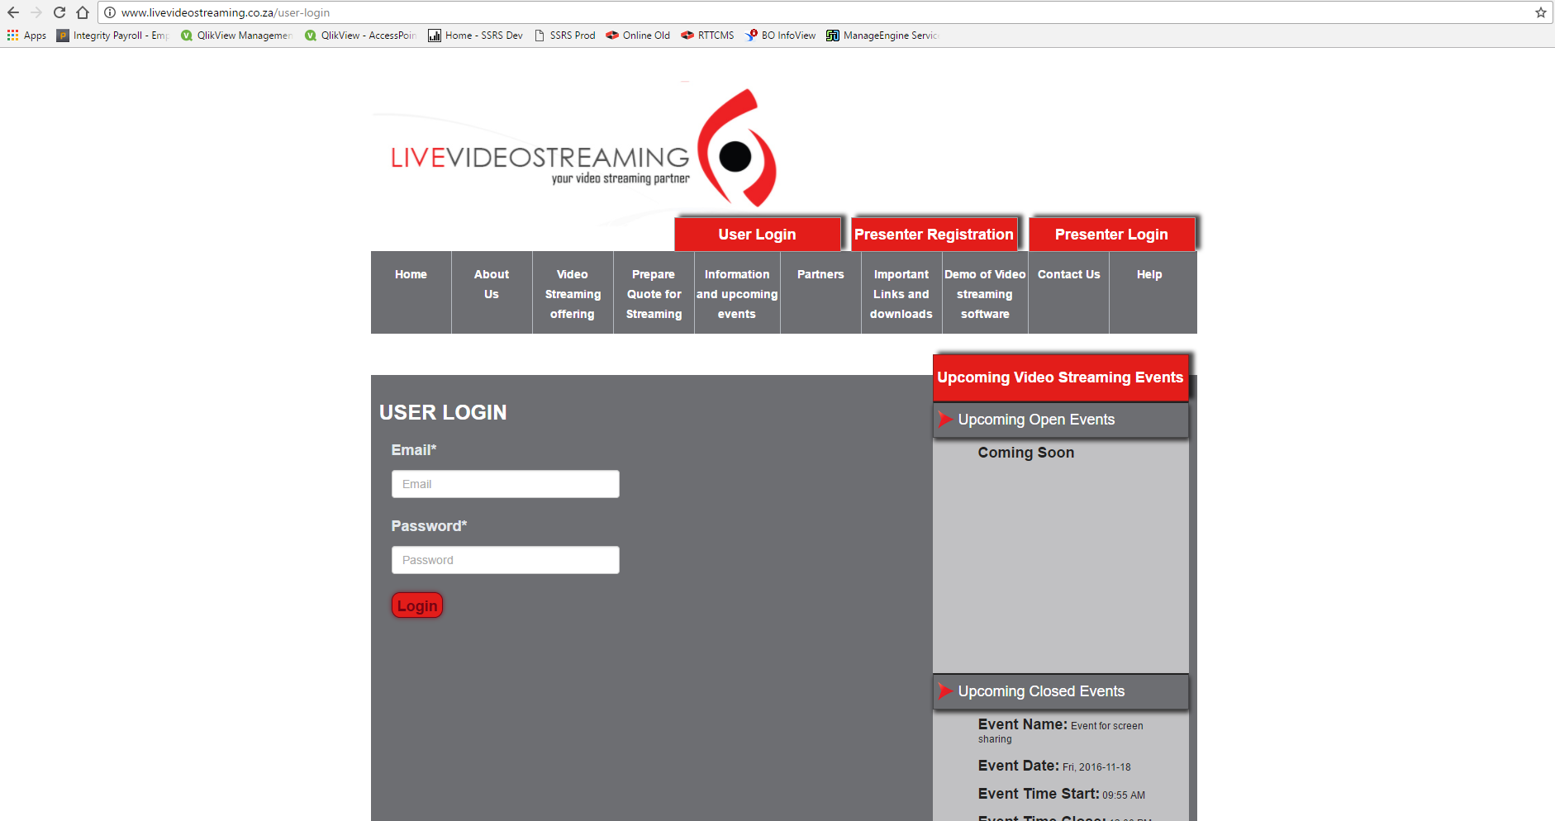

Now enter your email address and the password in the email that you have received, and click on the ‘Login’ button. This will log you into the live streaming video event.

Viewing live video stream
When logged in, you will be presented with the live video streaming screen. From this screen you will be able to do the following:
- View the live video stream from the presenter
- Listen to live audio from the presenter
- Enter messages/questions that you can direct at the presenter. The presenter will be able to read these messages and respond either via the video link or by typing a message back to you.
Please see an example of the live video streaming screen below:
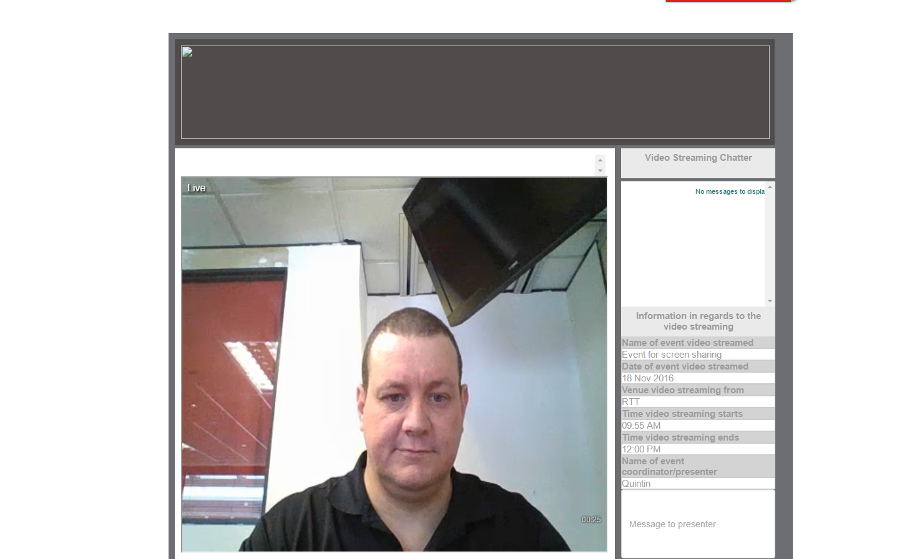

Viewing shared screen from presenter
If the presenter would like to share an application from his computer (i.e. Word, Excel, Powerpoint etc.) he will be able to do so from his screen. If he enables the screen share functionality, you will see the following screen (Please make sure that you allow popups for this site, otherwise the below window will not appear):
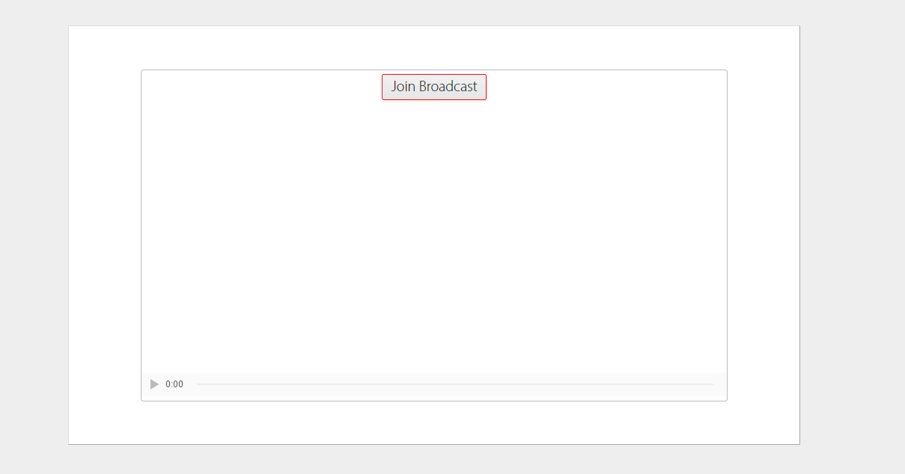
Click on the ‘Join Broadcast’ button. This will open the shared application from the presenter’s machine into a new window within you browser. See Below:
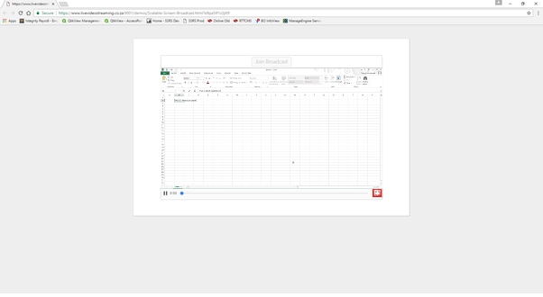
To make this screen full size, hover jour mouse over the bottom right hand corner of the image in your browser, and click on the little screen icon (see red block).
This will enlarge the screen to full size so that you can easily follow what the presenter is doing on his PC. See an example of the full screen application stream below:
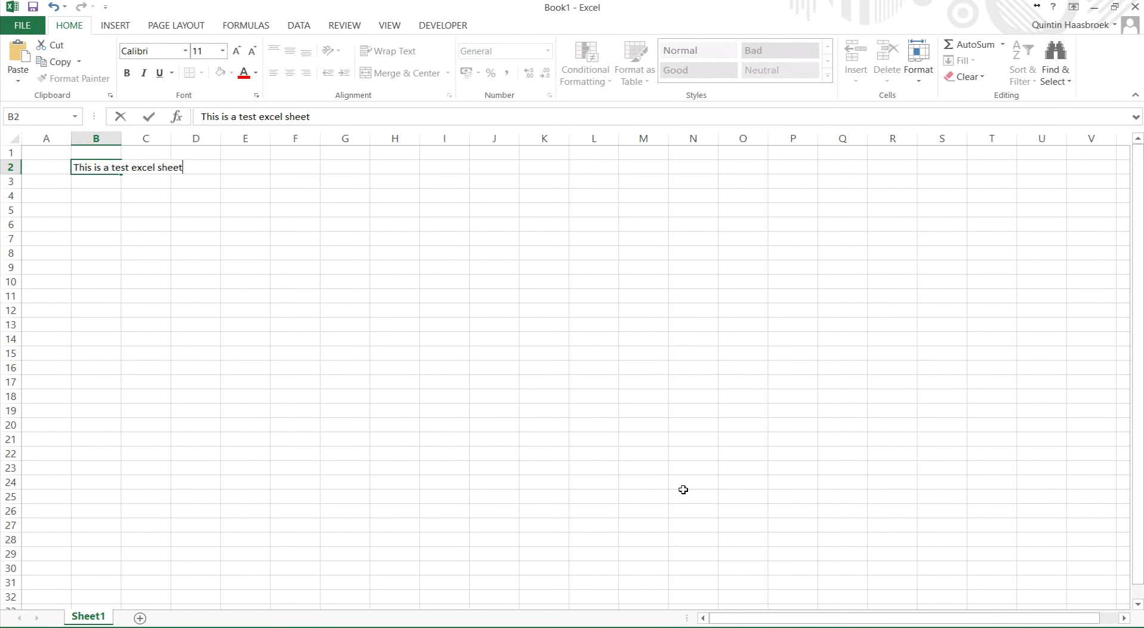
Once completed you can minimize the screen in the same manner that you maximized it, by hovering your mouse over the right bottom of the image and clicking the little screen icon. This will minimize the screen. You can then just close this tab, or move to the tab where the live video stream will still be active.

